Proposed Headline:
[INSERT FACILITY NAME] Adopts HeartFlow Analysis, a Novel Non-Invasive Diagnostic Tool for Heart Disease

Copy:
Physicians at [INSERT FACILITY NAME] now have access to the non-invasive HeartFlow FFR_{CT} Analysis, a personalized cardiac test that aids clinicians in diagnosing coronary artery disease (CAD). The HeartFlow FFR_{CT} Analysis is the first technology that uses standard coronary CTA scans to provide lesion-specific insights into both the extent of an arterial blockage and the impact that the blockage has on blood flow to the heart. This detailed information enables clinicians to determine the next step in the patient’s treatment plan.

The HeartFlow FFR_{CT} Process:
- If a patient has suspected coronary artery disease, a clinician may order a standard CCTA scan to look at the anatomy for blockages.
- If additional information is needed, a HeartFlow FFR_{CT} Analysis may be ordered to better understand the functional impact of the blockage (physiology/blood flow).
- Leveraging advanced algorithms incorporating AI and computational fluid dynamics, the HeartFlow FFR_{CT} Analysis digital 3D model is built, showing how each blockage limits blood flow.
- Within hours, the clinician receives the HeartFlow FFR_{CT} Analysis via a secure web interface and can assess, vessel by vessel, if sufficient blood flow is reaching the heart to better determine the best treatment path.

A CCTA ± FFR_{CT} first pathway has been supported by the ACC/AHA Chest Pain Guidelines and is already adopted by more than 725 hospitals worldwide, including 80% of the Top 50 Heart Hospitals in the US. New level 1 clinical evidence from the PRECISE trial, just presented as part of the Late-Breaking Clinical Sessions at AHA 2022, now shows that the CCTA ±FFR_{CT}-centered strategy is a frontline diagnostic pathway for patients with suspected CAD.

[INSERT CALL TO ACTION: LEARN MORE ON WEBPAGE, CONTACT SERVICE LINE, ETC.]

Optional Images:

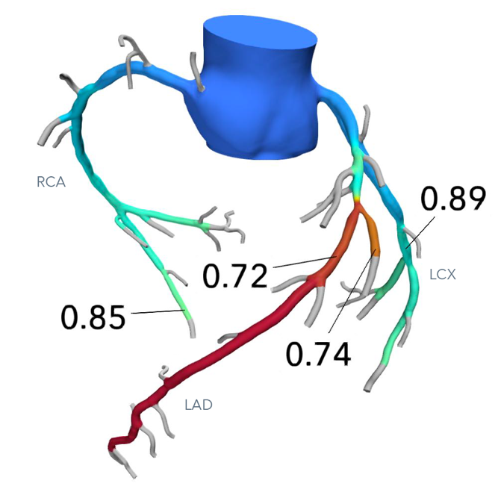
Click here to download the image above.

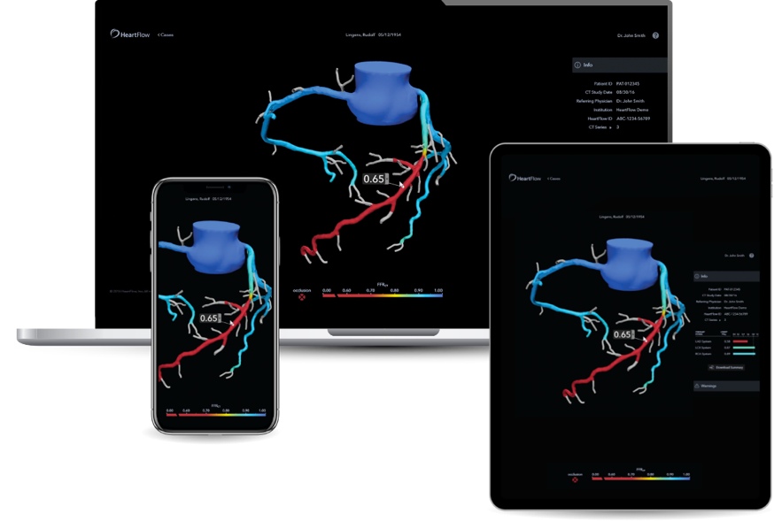

Click here to download the image above.

Click here to download the image above.

